***Practical 2***

**AIM: Static Keyword in PHP – Example,** **ECHO and PRINT statements in PHP – Example, strlen() and strpos() functions, strrpos, stripos – Example.**

* **Directory**

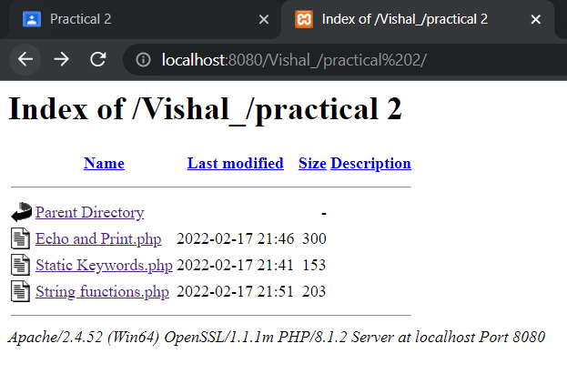

1. **Static Keyword in PHP**

Input

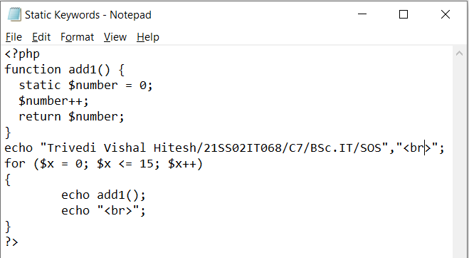

Output

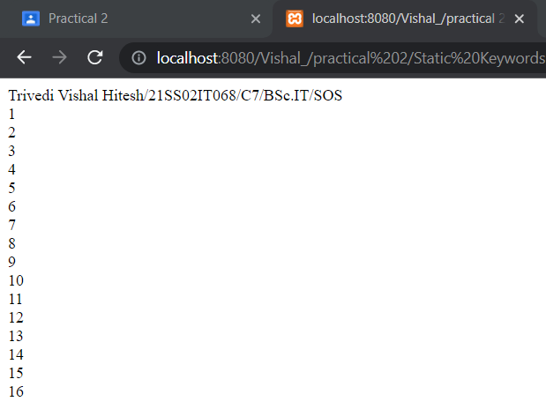

1. **ECHO and PRINT statements in PHP**

Input

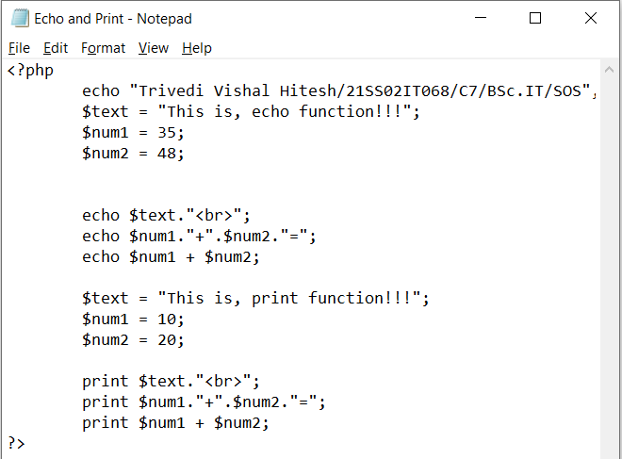

Output

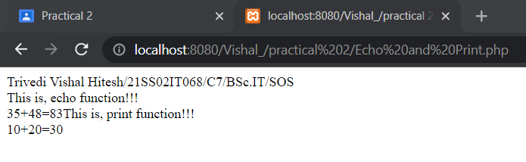

1. **strlen() and strpos() strrpos, stripos functions**

Input

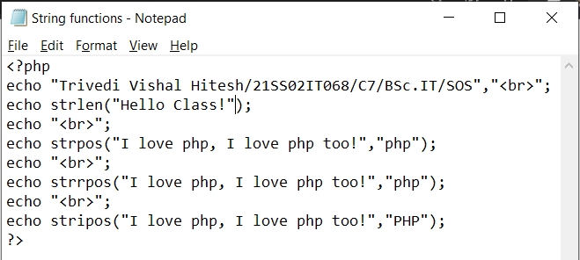

Output

